**SOUND HAPPENING QUICKSTART GUIDE**

2017 Project Leads

Dan Singer - [dsinger7@gatech.edu](mailto:dsinger7@gatech.edu)

Agneya Kerure - [kerure.agneya@gatech.edu](mailto:kerure.agneya@gatech.edu)

2016-2017 Project Contributors

Josh Moore - jmoore61gt@gmail.com

Pedro Arevalo - pedroarevel@gatech.edu

Donghai Liu - liudonghai1106@gmail.com

Components

-Ableton Live file

-Sound Happening Application (Max/MSP)

-Logitech Camera Settings app

In the Ableton Live file:

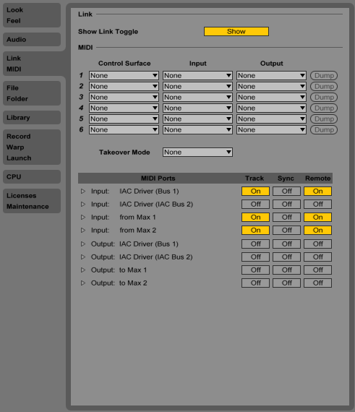

**Step 1:** Use the top toolbar to go to Preferences >> MIDI. Turn “Track” and “Remote” on for “Input: IAC Driver (Bus 1).”

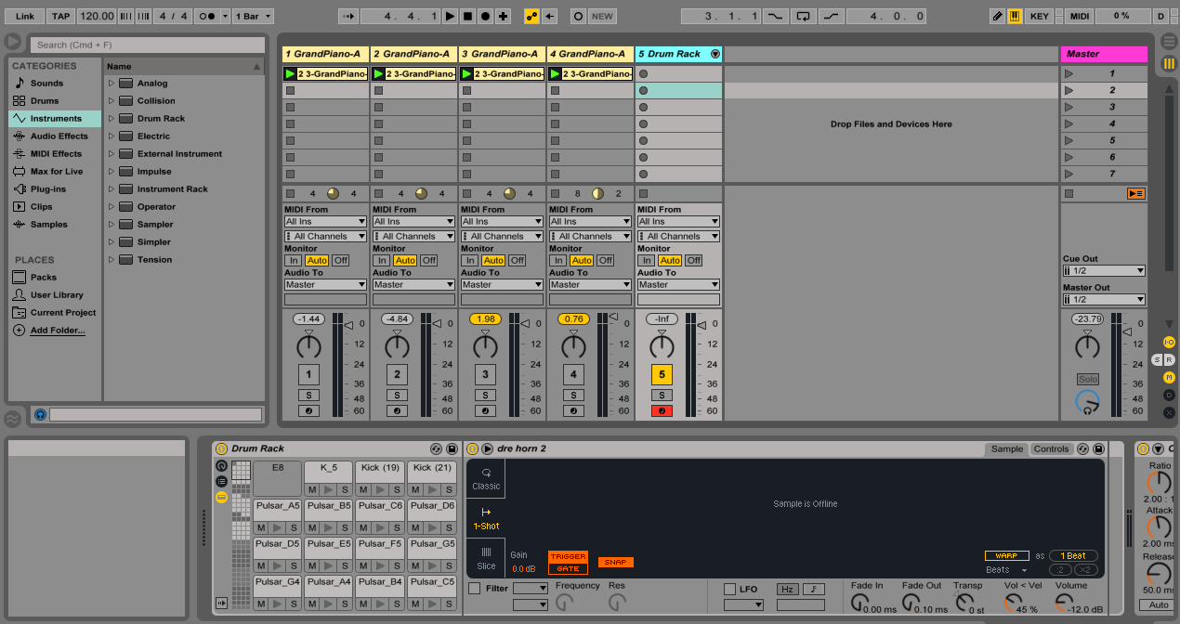

*The Ableton Live file receives MIDI messages from the Max/MSP application that trigger samples and software instruments.*



**Step 2:** Click the triangular “play” button in the top toolbar, causing it to turn green.

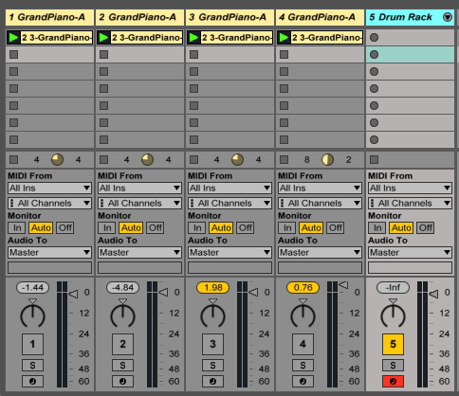

**Step 2:** When you initially load the file, make sure the “GrandPiano-A” tracks (1 through 4) have their corresponding rectangular numbered buttons (to the left of the gain meter) greyed out. This means they are deactivated. If one of these buttons is yellow and, therefore, activated, click it to deactivate it.

**Step 3:** When you initially load the file, make sure the “Drum Rack” track (5) is activated and has a yellow numbered button. In addition, click the “arm session” button next to the track activation button — it contains a clock symbol and will turn red.

*When the installation is running, the “GrandPiano-A” tracks will activate and deactivate automatically based on MIDI messages Ableton receives from Max/MSP.*

In the Sound Happening Application (Max/MSP):

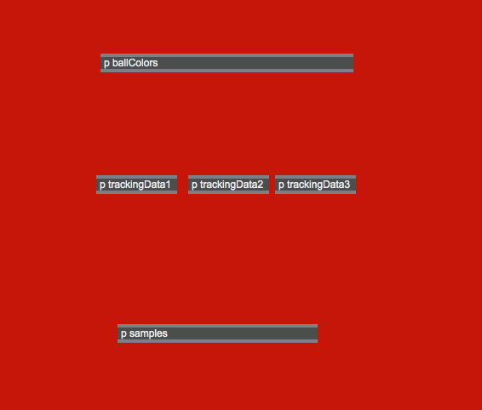

**Step 1:** Click the “p ballColors” object to open the “ballColors” subpatch.

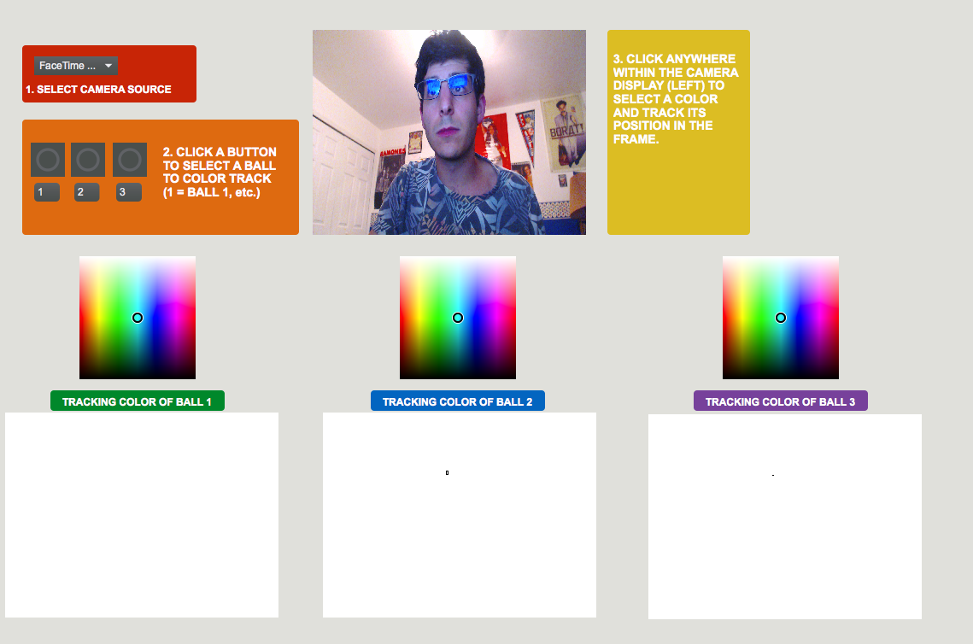

*This is the full view of the “ballColors” subpatch. You will use this subpatch to select the color of each ball that will be tracked.*

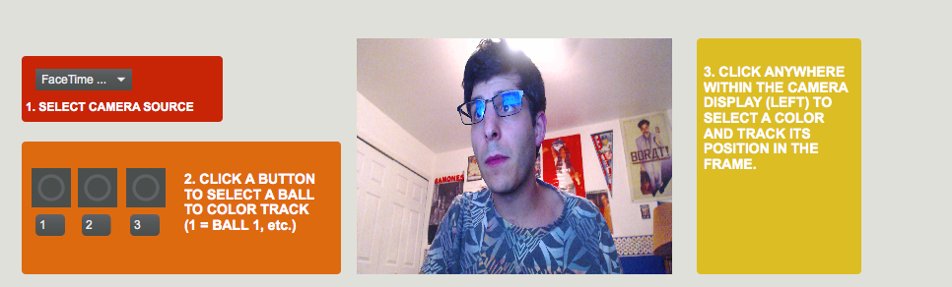

*Your webcam’s field of view is displayed in an object called a “pwindow.” Use the Logitech Camera Settings app to adjust lighting and color contrast seen within the “pwindow.”*

**Step 2:** Select your webcam source using the object highlighted with a red rectangle. Clicking on this object will open a dropdown menu where you can select a webcam source recognized by your computer.



**Step 3:** Click the circular button corresponding to the ball you will start tracking. In this setup, the button above the “1” is your first ball, the button above “2” is your second ball, and so on. This properly routes the color data you will obtain in Step 4.

**Step 4:** Click within the “pwindow” on an area of the ball that has a well-defined color (i.e. not too dark or washed out by bright light). An invisible object called “suckah” sits on top of the “pwindow,” and it identifies the RGB values of the pixel you have clicked.

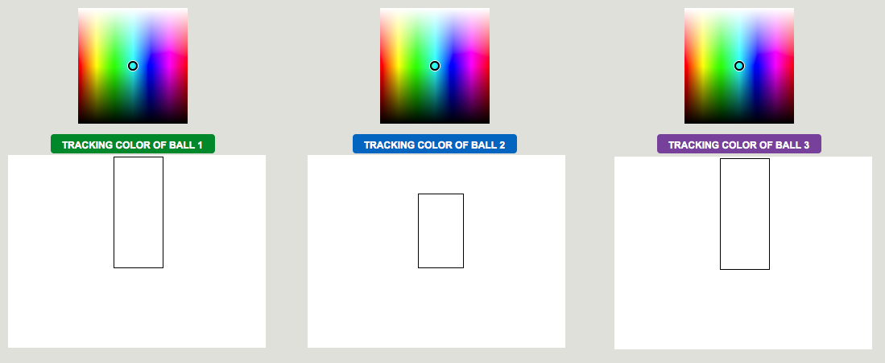

**Step 5:** Observe the white “pwindow” corresponding to the button you clicked, as it will display a black rectangle. This is the bounding box of the color that is being tracked. If the box consistently maintains its size and changes position in synchrony with the ball (as seen in the camera’s field of view), then the ball is being tracked accurately. If the bounding box takes up the entirety of the “pwindow” or rapidly changes size and position, then the ball is not being tracked accurately.

*Tracking problems usually occur when the ball’s color (or a similar color) appears elsewhere in the camera’s field of view. For example, if a light blue ball is on one side of the installation space and a participant’s light blue smartphone light is visible on the other side of the space, the bounding box will the envelop the locations of both sources of that color.*



**Step 6**: Repeat Step 4 as needed until the ball is being tracked accurately.

**Step 7:** Repeat Steps 3 - 6 until all of the balls are being tracked accurately. As of June 2017, the code base allows for tracking 3 balls in the installation.

In the Logitech Camera Settings app (only needed if using a Logitech webcam):

Free download: <https://itunes.apple.com/us/app/logitech-camera-settings/id638332853?mt=12>

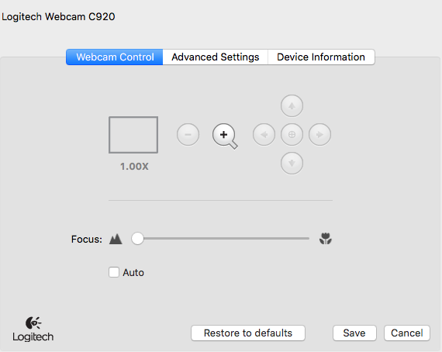

**Step 1:** Once your webcam is plugged in, uncheck the “Auto” button and drag the focus slider to its leftmost point.

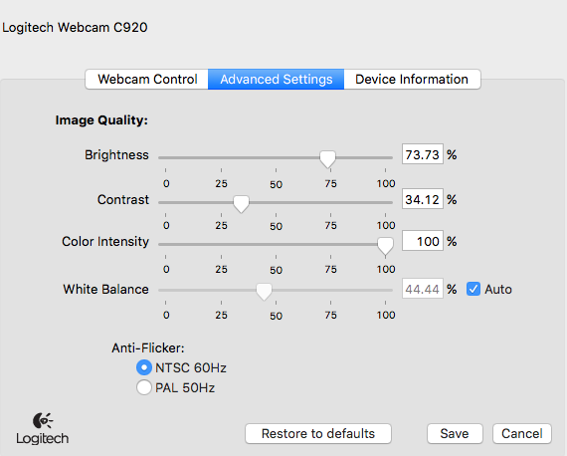

**Step 2:** Adjust the “Brightness,” “Contrast,” and “Color Intensity” sliders as needed. It is helpful to do this as you are setting up the Max/MSP application file.